**Luminance Pattern**

**Version 1.0**

**Version History**

|  |  |  |  |
| --- | --- | --- | --- |
| **Version** | **Date** | **Handled by** | **Comments** |
| V1.0 | 19-Aug-2019 | ZL Chen | First version release. |

Precondition Setting:

Please make sure the DUT is connected to the internet.

* Install the Python 3.6.8.
  + Please refer to the “Python 3.6.8 installation.pdf” attachment.

(\automation\sop\Python 3.6.8 installation.pdf)

* Install the wkhtmltox-0.12.5-1.msvc2015-win64.exe
  + Please refer to the “wkhtmltox installation.pdf” attachment.

(\automation\sop\wkhtmltox installation.pdf)

* Install the third party library.
  + Double click the “Envir_Install.exe” under the installer folder.

(\automation\installer\Envir_Install.exe)

Please follow the implement as below:

Step 1:

Please copy the folder of the suite to the device’s desktop.

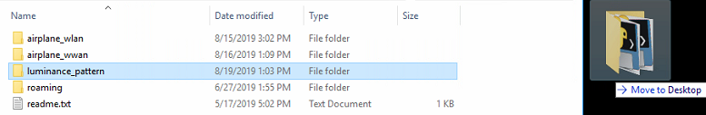

Implement the luminance_pattern.exe under the “\luminance_pattern\” folder, then input the information base on the specification.

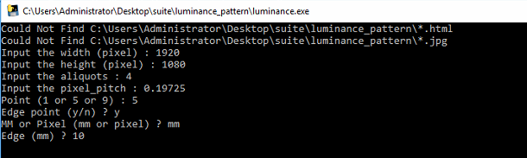

Step 2:

The program export the JPG data under the “\luminance_pattern\” folder.

